*Florida International University*

*School of Computing and Information Sciences*

CIS 4911 - Senior Capstone Project

Software Engineering Focus

Feature Document

User Story #1144

**Team Member:**

Shefali Nakum

**Product Owner(s)**:

Mohsen Taheri

**Mentor(s)**:

Mohsen Taheri

**Instructor**: Masoud Sadjadi

**User STORY:**

**Add Skill item in student application form and faculty proposal form.**

### **Description:**

* As a user, I would like to have a separate text box for skill item so that student can enter the skills that they have and professors can enter the skills that project requires.

### **Acceptance Criteria:**

1. While applying for project, developer has to access the website as a student.
2. While proposing for a project, developer has to access the website as a faculty.

**Use Case:**

### Participating Actors: Student and Faculty/Staffs. Entry Condition:

### Developer will navigate to the VIP website.

### Developer will log in to the VIP website.

### **Events Flow:**

**Part A**

* If Developer logs in as a Student and wish to apply for a project, then he will go to “Apply for a Project” form.
* Developer will notice a new field called “Skill Item” where he can enter the skills he is good at.
* When Developer enters the skills in the application form, this skill will reflect in the Developer’s Profile information with the same label called “Skill Item”.
* This Skill Item can be viewed in the project detailed information by clicking on the student name.
* This Skill Item can also be viewed by the admin in review user and can approve based on the Skill Item.

**Part B**

* If Developer logs in as a Professor, and wish to propose a project, then he will go to “Propose a Project” tab.
* Developer will then fill the form and notice a new field called “Skill Item” where he can enter the desired skills he is looking in the students.
* This information can be viewed in VIP Project detailed information.

**Use Case Diagram**

* When student applies for a project.

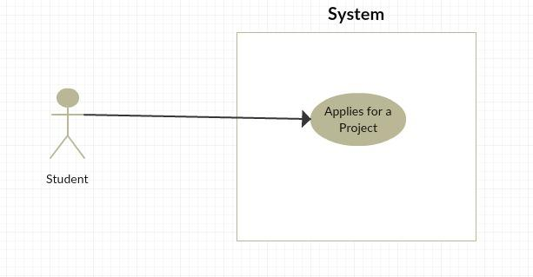

* When professor proposes a project

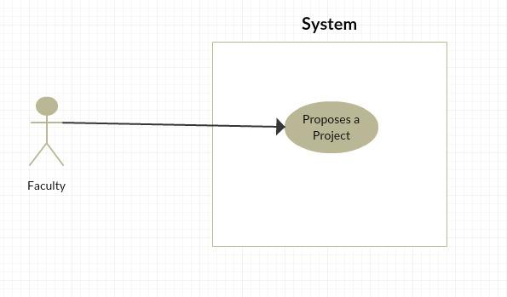

**Sequence Diagram**

**N/A**

**Class Diagram**

**N/A**

**Unit & Integration Tests**

**Test Case 1 (Sunny Day)**

**Purpose**

* When student enters skill item in the application form for a project then it should reflect in his profile.

**Precondition**

* Developer must log in to the website as a student and can apply for a project, encountered no errors while doing so.

**Input**

* Developer enters skill item and clicks on the “Submit” button at the bottom of the page.

**Expected Result**

* Data added to the user profile and can be viewed by the professor.

**Actual Result**

* Same as expected.

**Test Case 2 (Sunny Day)**

**Purpose**

* While proposing any project, professor should be able to mention required skill item for his project.

**Precondition**

* Developer has to log in to the website as professor and encountered no errors while doing so.

**Input**

* Developer enters required skill item and clicks on the “Submit” button at the bottom of the page.

**Expected Result**

Data will go to the Database.

**Actual Result**

* Same as expected.

**Test Case 3 (Rainy Day)**

**Purpose**

* Ensure project application must contain valid data for all required fields (skill item)

**Precondition**

* Student has reached the VIP site and reached apply for project application form/ Propose a project form.

**Input**

* Student leaves a required field blank or inputs invalid data

**Expected Result**

* Submit button becomes disabled

**Actual Result**

* Submit button becomes disabled

**Visual User Guide**

* **STUDENT APPLYING FOR PROJECT**

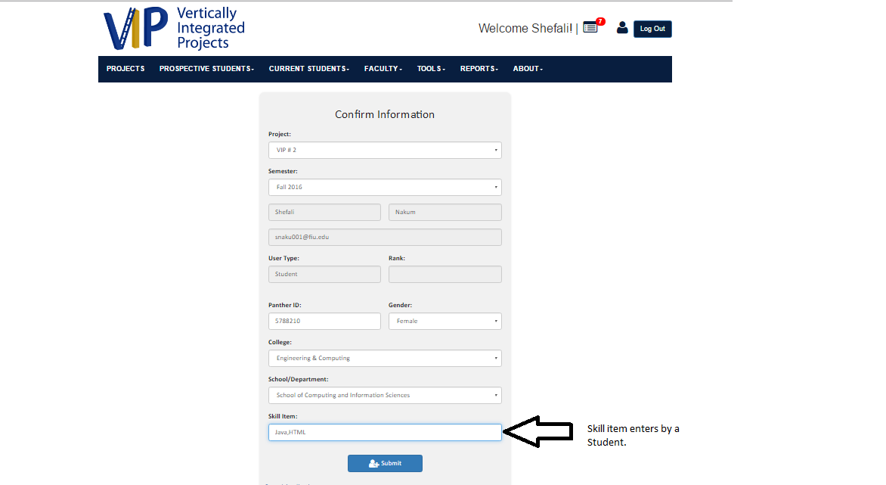

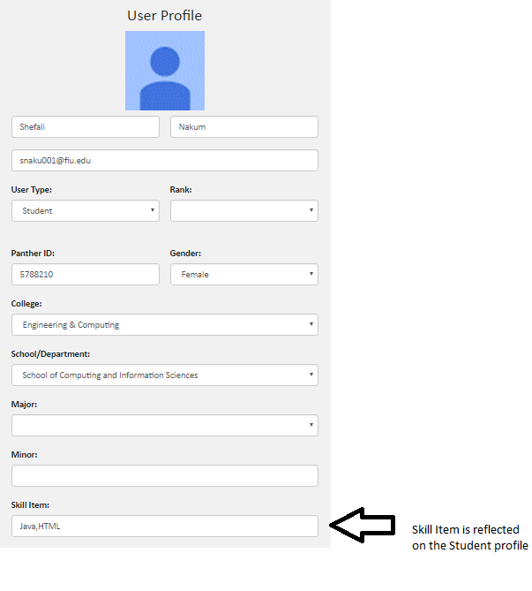

* **PROFESSOR PROPOSING A PROJECT**

